TECHNICAL PROJECT REPORT

# Title of Invention / Project: Ultrasonic parking sensor

# Team Members / Inventors:

|  |  |  |  |  |  |
| --- | --- | --- | --- | --- | --- |
| **S.No.** | **Name** | **Department** | **Designation** | **Mobile** | **E-Mail** |
| 1. | Rohit Kumar | ECE | STUDENT | 8685911101 | rohitkumar.241099@gmail.com |
| 2. | Avinash | ECE | STUDENT | 8250590056 | shrankistiiit@gmail.com |
| 3. | Sahil Shanavas | ECE | STUDENT | 9924552797 | Sahilshanavas06@gmail.com |
| 4. | Khushal Thakur | ECE | Mentor | 9646030764 | khushal.thakur@cumail.in |
| 5. | Anshul Sharma | ECE | Mentor | 9478697475 | anshulsharma.ece@cumail.in |
| 6. | Kiran Jot Singh | ECE | Mentor | 9463909689 | kiranjotsingh.ece@cumal.in |
| 7. | Divneet Singh Kapoor | ECE | Mentor | 9878422653 | divneet.ece@cumail.in |

Section – 1 (IPR Related)

# **Brief Abstract :**

* Problem your project is solving- our project is used to park vehicles safely. It prevent minor damages to vehicles.
* How are you solving that – by using ultrasonic sensor we make a device which we named autoparker and it can notify us while parking vehicle by blinking led at some specific range.
* Additional modifications that can cater to improvedsolution – we can add buzzer which make sound when vehicle is in that range .

# Existing state-of-the-art and Drawbacks in existing state-of-the-art

|  |  |  |
| --- | --- | --- |
| **S. No.** | **Existing state of art** | **Drawbacks in existing state of art** |
| 1 | RFID technology based parking sensor system | We Radio Frequency Identification system and it is connected to every sensor which sometimes gets distracted through others signals. |

# Novel/Additional modifications that you can propose to improve upon drawbacks:

* Do not require any frequency dependent system.
* Switch on and off in smarter way.

# **Advantages:**

* Prevent damages to vehicles while parking.
* Also saves time while parking.
* Sometimes we don’t need others advise while parking.

Section – 2 (Real Project)

# **Materials**

|  |  |  |
| --- | --- | --- |
| **S. No.** | **Name of material** | **Price of material** |
| 1 | Aurdino Uno | Rs. 400 |
| 2 | Ultrasonic Sensor (HC-SR040 | Rs. 150 |
| 3 | Breadoard | Rs. 80 |
| 4 | Jumper Wires | Rs. 20 |
| 5 | Red Led | Rs. 5 |

# **Circuit Diagram**

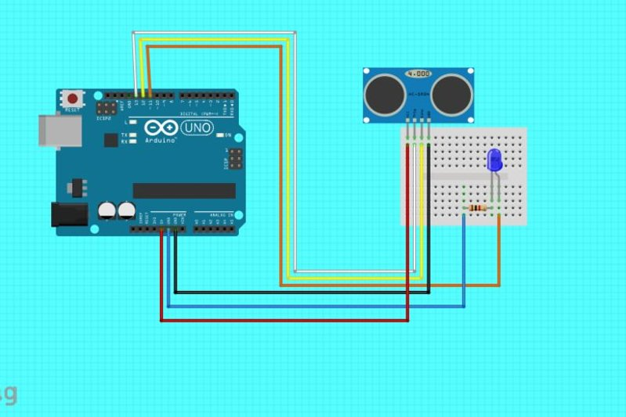

# **Steps of Circuit Completion**:

1. Take Arduino.
2. Then breadboard.
3. Connect Wires acoording to connections
4. Connect Led and its connections.
5. Joined all the connections.
6. Make programm code and upload it on the aurdino.

# **Program Code**

https://github.com/RohitKumar625/beee.git